**Implementation of FIFO (FIRST – IN FIRST – OUT)**

**using AXI-4 Stream protocol**

**What is FIFO ?**

In modern System-on-Chip (SoC) and FPGA-based designs, high-performance data transfer between different modules is a critical requirement. One of the most widely used methods to achieve efficient and reliable data movement is by using First-In-First-Out (FIFO) buffers.

A **FIFO** (First-In, First-Out) is a buffer that stores data temporarily and outputs it in the same order it was received.

**Why we need FIFO ?**

* It’s used to handle **rate mismatches** between producer and consumer modules, e.g., when one block generates data faster than another block can consume.
* It’s also used in **clock domain crossing (CDC)** to safely pass data between two clock regions.
* **Burst Handling** – If input comes in bursts but the output can only process steadily (or vice versa).
* **Decoupling** – It avoids stalling one module while another is busy.

**Basic architecture of a FIFO :**

A hardware FIFO has:

1. **Memory array** – stores the actual data (reg [W-1:0] mem[DEPTH-1:0]).
2. **Write pointer (wr_ptr)** – It points to the next location to write data in.
3. **Read pointer (rd_ptr)** – It points to the next location to read data from.
4. **Control logic** – generates flags (full, empty, sometimes almost_full, almost_empty).
5. **Optional counters** – track number of stored elements.

**AXI FIFO Concept:**

An **AXI FIFO** is generally a FIFO memory buffer that provides an **AXI4-Stream slave interface** on the input side and an **AXI4-Stream master interface** on the output side.

* **Write side (Slave interface):** Accepts data when s_valid and s_ready are high.
* **FIFO Memory:** Stores data sequentially.
* **Read side (Master interface):** Provides data when m_valid and m_ready are high.

**Wr_ptr**

**Rd_ptr**

**M_ready**

**M_valid**

**M_data**

**S_ready**

**S_data**

**S_valid**

SLAVE

FIFO

|  |
| --- |
|  |
|  |
|  |
|  |
|  |
|  |
|  |
|  |
|  |
|  |

MASTER

Block diagram of AXI FIFO

**Applications of FIFO:**

FIFO is used in many digital systems:

* **AXI4-Stream Interfaces** – To buffer data between processing IP blocks.
* **UART, SPI, I2C Controllers** – To store received/transmitted data temporarily.
* **Network Routers / Switches** – Packets buffered before forwarding.
* **Multimedia (Video/Audio pipelines)** – Streaming pixels, audio samples, frames.
* **Data Converters (ADC/DAC)** – Handling mismatched rates between converters and processors.

**Types of FIFO:**

* Synchronous FIFO – It uses same clock for both read and write. Simpler logic (pointers can be compared directly).
* Asynchronous FIFO (CDC FIFO) - Read and write have different clocks.

**Implementation:**

1. Using pointer comparison: We compare wr_ptr & rd_ptr for both flags.

Full = (wr_ptr +1 == rd_ptr) or Full = (wr_ptr +1 ) % Depth == rd_ptr)

Empty = (wr_ptr == rd_ptr) or Empty = (wr_ptr == rd_ptr) && !Full

These conditions are for one-slot method where we reserve one memory to compare pointers.

1. Using counter : We count how many data-words are written into the memory and how many data-words are read from the memory.

Empty = (count == 0)

Full = (count == Depth)

**METHOD 1 – Using pointers comparison**

**Design code:**

module fifo_axi#(parameter DATA_WIDTH=32, FIFO_DEPTH=16)(

//Global Signals

input aclk, aresetn,

//Input slave interface

input [DATA_WIDTH-1:0] s_data,

input s_valid,

output s_ready,

//Output master interface

output reg [DATA_WIDTH-1:0] m_data,

output m_valid,

input m_ready);

//fifo parameters

localparam ptr_width = $clog2(FIFO_DEPTH);

reg [DATA_WIDTH-1:0] fifo_mem [0:FIFO_DEPTH-1]; // memory array

reg [ptr_width-1:0] rd_ptr,wr_ptr; // read and write pointers

wire full = (wr_ptr+1'b1)== rd_ptr; // using one slot method

wire empty = (rd_ptr == wr_ptr) && !full ; // when both pointers are same, the fifo indicates

empty

assign s_ready = !full;

assign m_valid = !empty;

wire rd_en = (m_valid && m_ready);

wire wr_en = (s_valid && s_ready);

always@(*) begin

if(empty) m_data <= 32'hx;

else m_data <= fifo_mem[rd_ptr];

end

always@(posedge aclk or negedge aresetn) begin

if(!aresetn) begin

wr_ptr <= 0;

rd_ptr <= 0;

m_data <= 0;

end

else

begin

//Writing data into the FIFO

if (wr_en)

begin

fifo_mem[wr_ptr] <= s_data;

wr_ptr <= wr_ptr + 1 ;

end

//Reading data from FIFO

if (rd_en)

begin

//m_data <= fifo_mem[rd_ptr];

rd_ptr <= rd_ptr + 1;

end

end

end

endmodule

**Test bench:**

module axi_fifo_tb();

parameter DATA_WIDTH = 32;

parameter FIFO_DEPTH = 16;

reg aclk;

reg aresetn;

// Slave interface

reg [DATA_WIDTH-1:0] s_data;

reg s_valid;

wire s_ready;

// Master interface

wire [DATA_WIDTH-1:0] m_data;

wire m_valid;

reg m_ready;

integer i,j,wi,ri;

// DUT instantiation

fifo_axi #(DATA_WIDTH,FIFO_DEPTH) dut

(aclk,aresetn,s_data,s_valid,s_ready,m_data,m_valid,m_ready);

// Clock generation

initial aclk=0;

always #5 aclk = ~aclk;

initial begin

aresetn = 0;

s_valid = 0;

s_data = 0;

m_ready = 0;

#20 aresetn = 1;

end

task write_fifo(input [DATA_WIDTH-1:0] din);

begin

@(posedge aclk);

s_valid=1;

s_data=din;

@(posedge aclk);

s_valid=0;

end

endtask

task read_axififo();

begin

@(posedge aclk);

m_ready=1;

@(posedge aclk);

m_ready=0;

end

endtask

initial begin

@(posedge aresetn);

@(posedge aclk);

$display("Writing data into fifo");

for(i=0; i<FIFO_DEPTH; i=i+1)

begin

write_fifo($urandom);

$display(" %h data written in fifo",i);

End

$display("Reading data from fifo");

for(j=0; j<FIFO_DEPTH; j=j+1)

begin

$display(" %h data read from fifo",j);

read_axififo();

end

$display("Simultaneous write and read operation to fifo");

fork

begin

for(wi=0; wi<=30; wi=wi+1) begin

write_fifo($urandom);

end

end

begin

for(ri=0; ri<=31; ri=ri+1)begin

read_axififo();

end

end

join

#50;

$finish;

end

endmodule

**Simulation Results:**

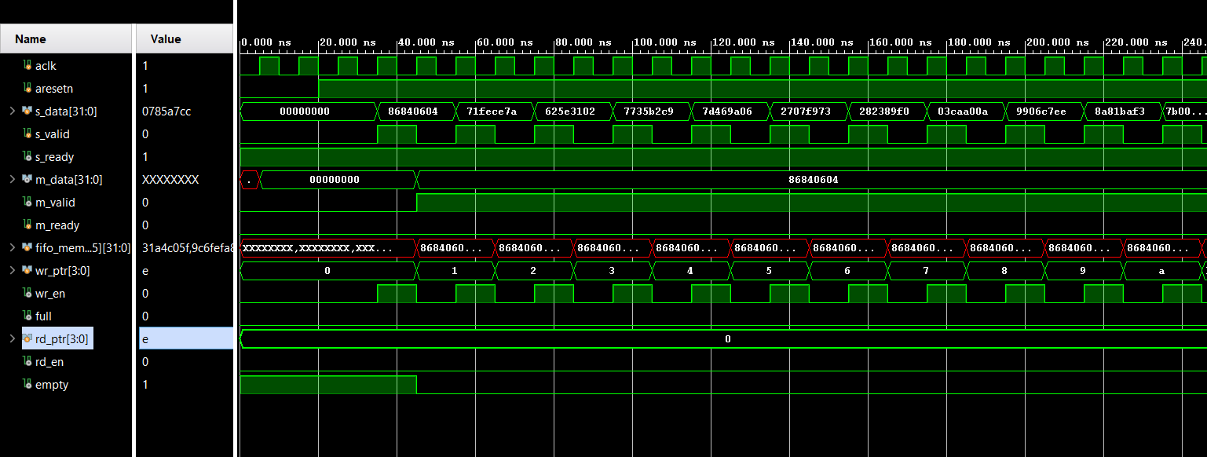

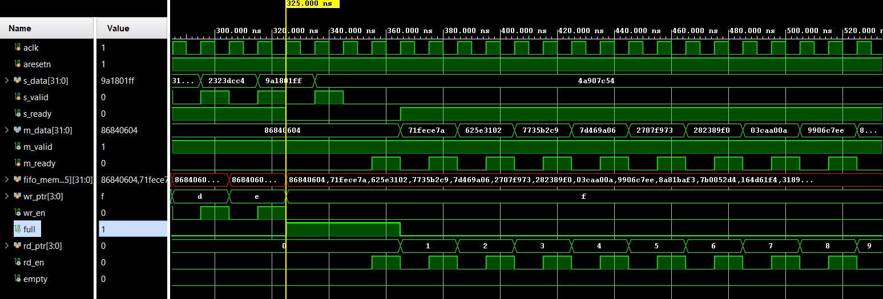

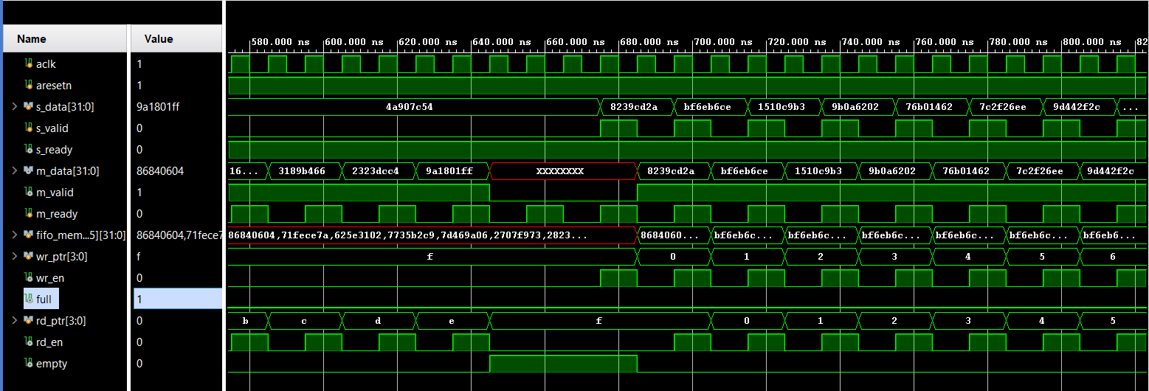

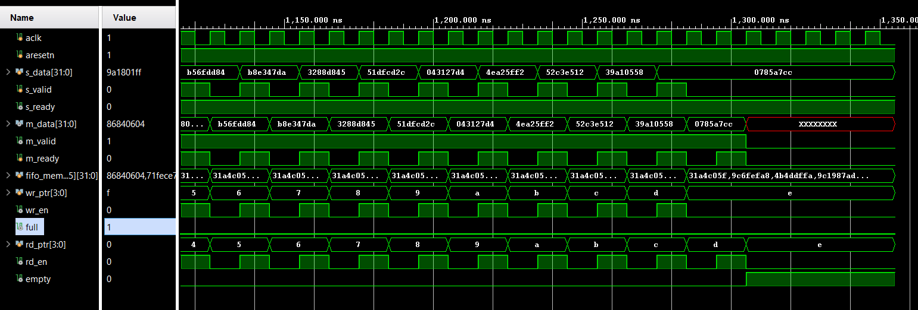

**METHOD 2 – Using counter**

**Design code:**

module fifo_axi #(parameter DATA_WIDTH=32, FIFO_DEPTH=16)(

//Global Signals

input aclk, aresetn,

//Input slave interface

input [DATA_WIDTH-1:0] s_data,

input s_valid,

output s_ready,

//Output master interface

output reg [DATA_WIDTH-1:0] m_data,

output m_valid,

input m_ready

);

//fifo parameters

localparam ptr_width = $clog2(FIFO_DEPTH);

reg [DATA_WIDTH-1:0] fifo_mem [0:FIFO_DEPTH-1]; // memory array

reg [ptr_width-1:0] rd_ptr,wr_ptr; // read and write pointers

reg [ptr_width:0]count;

wire empty = (count == 0);

wire full = (count == FIFO_DEPTH);

assign s_ready = !full;

assign m_valid = !empty;

wire rd_en = (m_valid && m_ready);

wire wr_en = (s_valid && s_ready);

always@(*) begin

if(empty) m_data = 32'hx;

else m_data = fifo_mem[rd_ptr];

end

always@(posedge aclk or negedge aresetn)

begin

if(!aresetn) begin

wr_ptr <= 0;

rd_ptr <= 0;

count <= 0;

end

else begin

//Writing data into the FIFO

if (wr_en)

begin

fifo_mem[wr_ptr] <= s_data;

wr_ptr <= wr_ptr + 1 ;

end

//Reading data from FIFO

if (rd_en)

begin

rd_ptr <= rd_ptr + 1;

end

case({wr_en , rd_en})

2'b10 : count <= count + 1;

2'b01 : count <= count - 1;

default : count <= count;

endcase

end

end

endmodule

**Test bench:**

module fifo_axitb();

parameter DATA_WIDTH = 32;

parameter FIFO_DEPTH = 16;

reg aclk;

reg aresetn;

// Slave interface

reg [DATA_WIDTH-1:0] s_data;

reg s_valid;

wire s_ready;

// Master interface

wire [DATA_WIDTH-1:0] m_data;

wire m_valid;

reg m_ready;

integer i,j,w_done,r_done,x,y;

// DUT instantiation

fifo_axi #(DATA_WIDTH,FIFO_DEPTH) dut

(aclk,aresetn,s_data,s_valid,s_ready,m_data,m_valid,m_ready);

// Clock generation

initial aclk=0;

always #5 aclk = ~aclk;

initial begin

aresetn = 0;

s_valid = 0;

s_data = 0;

m_ready = 0;

#20 aresetn = 1;

end

task write(input [DATA_WIDTH-1:0] in, output integer wf);

begin

@(posedge aclk);

wf=0;

s_valid = $urandom_range(0,1);

if(s_valid) begin

s_data = in;

wf=1;

// #10;

//s_valid=0;

end

else s_valid = 0;

@(posedge aclk);

end

endtask

task read(output integer rf);

begin

@(posedge aclk);

rf=0;

m_ready=$urandom_range(0,1);

if(m_ready) begin

rf=1; //#10;

//m_ready=0;

end

end

endtask

initial begin

@(posedge aresetn);

@(posedge aclk);

$display("Writing data into fifo until it's full ");

i=0;

while(i<=FIFO_DEPTH)

begin

//@(posedge aclk);

write($random,w_done);

if(w_done) i=i+1;

#10;

s_valid=0;

end

s_valid=0;

$display("Reading data from fifo until it's empty ");

j=0;

while(j<=FIFO_DEPTH) begin

read(r_done);

if(r_done) j=j+1;

#10;

end

m_ready=0;

$display("Simultaneous writing and reading data for fifo ");

fork

begin

x=0;

while(x<=(FIFO_DEPTH+FIFO_DEPTH))

begin

@(posedge aclk);

write($random,w_done);

if(w_done) x=x+1;

#10;

s_valid=0;

end

end

begin

y=0;

while(y<=(FIFO_DEPTH+FIFO_DEPTH)) begin

read(r_done);

if(r_done) y=y+1;

#10;

end

end

join

#20 $finish;

end

endmodule

**Simulation Results:**

